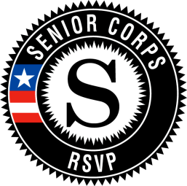

Massachusetts Senior Corps Association

Senior Corps provides service opportunities for Americans 55 and over by connecting you with the people and organizations that need you most. We offer three national programs: Foster Grandparents, Senior Companions, and RSVP.

As of March 2014, 7055 participants serve in 28 Senior Corps programs across Massachusetts. Local programs are sponsored by municipal or nonprofit agencies and receive funding from the Corporation for National and Community Service.

Visit http://maseniorcorps.weebly.com to find Senior Corps programs near you.

Foster Grandparents
You’re a role model, a mentor, and a friend. Serving at one of thousands of local organizations, you help children learn to read.

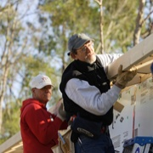
RSVP offers a range of volunteer opportunities in national focus areas:

- Capacity Building
- Disaster Services
- Economic Opportunity
- Education
- Environmental Stewardship
- Healthy Futures
- Veterans and Military Families

Senior Companions
Whether you're giving families or professions caregivers much-needed time off, running errands, or simply being a friend, you'll make a difference

